KPC PUBLIC SCHOOL KHARGHAR
Term – I (2022-2023)

STD : VI MARKS : 50 SUBJECT : MATHS TIME: 2 HRS

Q.1. Choose the correct option (6 marks)
1. The number of times that a particular entry occurs is called:
(a) Frequency (b) Class-interval (c) Raw data (d) Range
2. Using the digits 1, 5, 7, 2 without repetition, the greatest 4-digit number that can be made is
(a) 7521 (b) 7512 (c) 7215 (d) 7251
3. On a number line, when we add a positive integer, we
(a) move to the right (b) move to the left (c) do not move at all (d) none of these.
4. The side of a regular pentagon is l. Its perimeter is
(a) 3l (b) 6l (c) 4l (d) 5l
5. 275 is divisible by
(a) 5 (b) 3 (c) 6 (d) 8
6. Express $\frac{45}{7}$ as a mixed fraction.
(a) 6 $\frac{3}{7}$ (b) 7 $\frac{3}{9}$ (c) 4 $\frac{5}{7}$ (d) 6 $\frac{4}{7}$

Q.2. Solve the following (8 marks)
1. For two parts out of seven we say ‘two-seventh’ and write 2/7.
(i) For ‘four parts out of five’ we say ________ and write _______ .
(ii) For ‘nine parts out of seventeen’ we say _______ and write _______
2. Frame algebraic expressions for the following. State what each variable stands for.
The area of a rectangle is the product of its length and breadth.
Solution:
Let the area of a rectangle be A
Let the length of a rectangle be _____
Let the base of a rectangle be _____
A = __ × ___
Where A = Area of a rectangle
____ = Length of a rectangle
____ = Base of a rectangle
3. Represent the following numbers as integers with appropriate signs.
a. A submarine is moving, nine hundred metre below the sea level.
b. An aeroplane is flying, two thousand five hundred metre above the ground.
4. Add using a Number line
11 + (- 16)
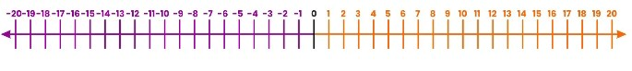
Q.3. Solve the following (9 marks)
1. Raju takes a right turn and walks 95 steps to reach his house. One day, he takes a left turn and walks 32
steps towards the opposite direction. How many steps does he need to walk back to reach his house?
2. The HCF of two numbers is 4 and their LCM is 168. If the first number is 12, find the other number.
3. Write an equivalent fraction for each of the following
a. $\frac{7}{9}$ with 63 as the denominator
b. $\frac{4}{7}$ with 24 as the numerator

Q.4. Solve the following (any 3) (12 marks)
1. Verify whether the following are true or not.
a. | 2 + (- 7)| = | 2| + |- 7|
b. | - 2 - 3| = | (- 2) + (- 3)|
2. Draw the following shapes and show all the possible lines of symmetry.
a. Regular octagon
b. Isosceles trapezium
3. Observe the given bar graph and answer the following questions.
a. Which fruit is sold the most?
b. How many more oranges were sold than bananas?
c. How many fruits were sold altogether?
d. If the price of a dozen apples is 125, then how much amount did the fruitseller earn by selling the
apples?

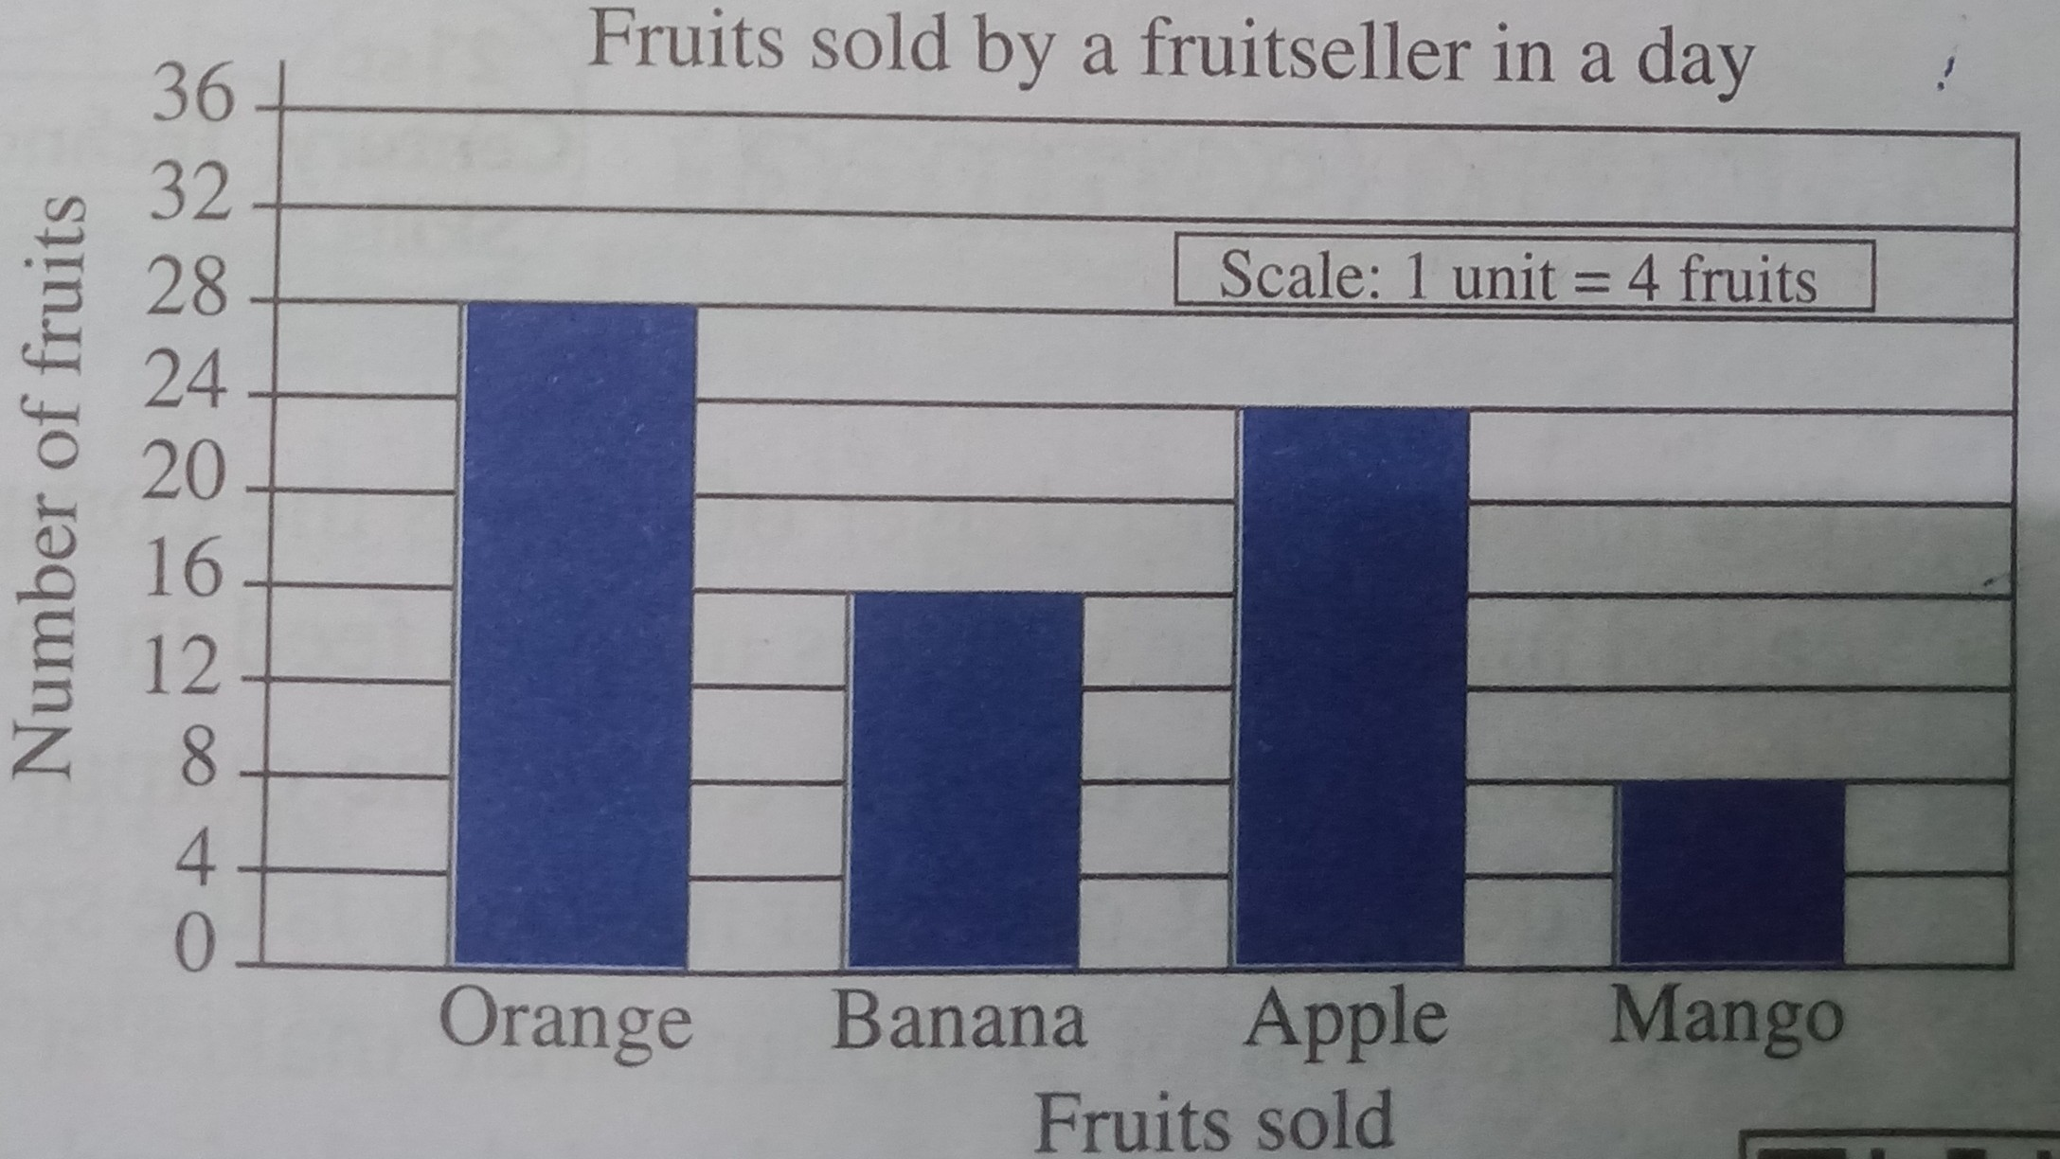

4. Arrange the following fractions
a. In Ascending order
$\frac{2}{5}$ , $\frac{3}{4}$ , $\frac{7}{12}$ , $\frac{11}{20}$
b. In Descending order
$\frac{4}{9}$ , $\frac{7}{12}$ , $\frac{2}{3}$ , $\frac{11}{20}$

Q.5. Solve the following (any 3) (15 marks)
1. As a part of a 10 $\frac{1}{2}$ km long race, 5 $\frac{2}{3}$ km was to be covered on cycles, 1 $\frac{7}{11}$ km by boats and the rest on
foot. Find out the distance travelled by the athletes on foot.
2. Add the following Integers
a. 27 + (- 54) + (- 32) + 65 + 46
b. 15 + (-2 ) + 7 + 14 + (- 5) + (- 12)
3. a) A survey, carried on 30 students of class IV in a school, about different modes of transport used by the
children to travel to school is as follows.
School Bus, Cycle, Bike, Walking, School Bus, Cycle, School Bus, Walking. Cycle, Bike, School Bus.
Cycle, Car, Walking, Cycle, Bike, School Bus, Cycle, Car, Bike, School Bus, Walking. Cycle, Bike.
School Bus, Bike, Car, School Bus, Walking, School Bus Organise the above data using tally marks.

b) Construct a bar graph to show the number of students who passed out from a school in five years.
Year | 2006 | 2005 | 2004 | 2003 | 2002
Number of Students | 91 | 100 | 89 | 93 | 120

4. Solve the following Fractions
a. 2 $\frac{3}{11}$ + 4 $\frac{1}{9}$ + $\frac{1}{3}$
b. 5 $\frac{11}{18}$ - 2 $\frac{7}{12}$ + 1 $\frac{2}{3}$

